The following documentation is a breakdown of how to make and how to review a pull request.

Reviewing a Pull Request from GitHub

# Select the pull request tab

# 

# Select open new pull request

# Select your branch from the drop down list in “compare”

# Select “create pull request”

# Add title and description for your pull request

Title must include which team you are (DATA SCIENCE or WEBDEV)

Name of what you are working on (This should match what is on your Trello card)

Percentage of completion of your use case from Trello

Description must include reason for pull, e.g. use case completed, Sprint 1 pull request.

Description must include a list of the changes that have been made to your folder since last making a pull request.

# 

# Select reviewers and choose 2 reviewers

One reviewer can be any member of your team, the other MUST be a leadership student.

# Create your pull request

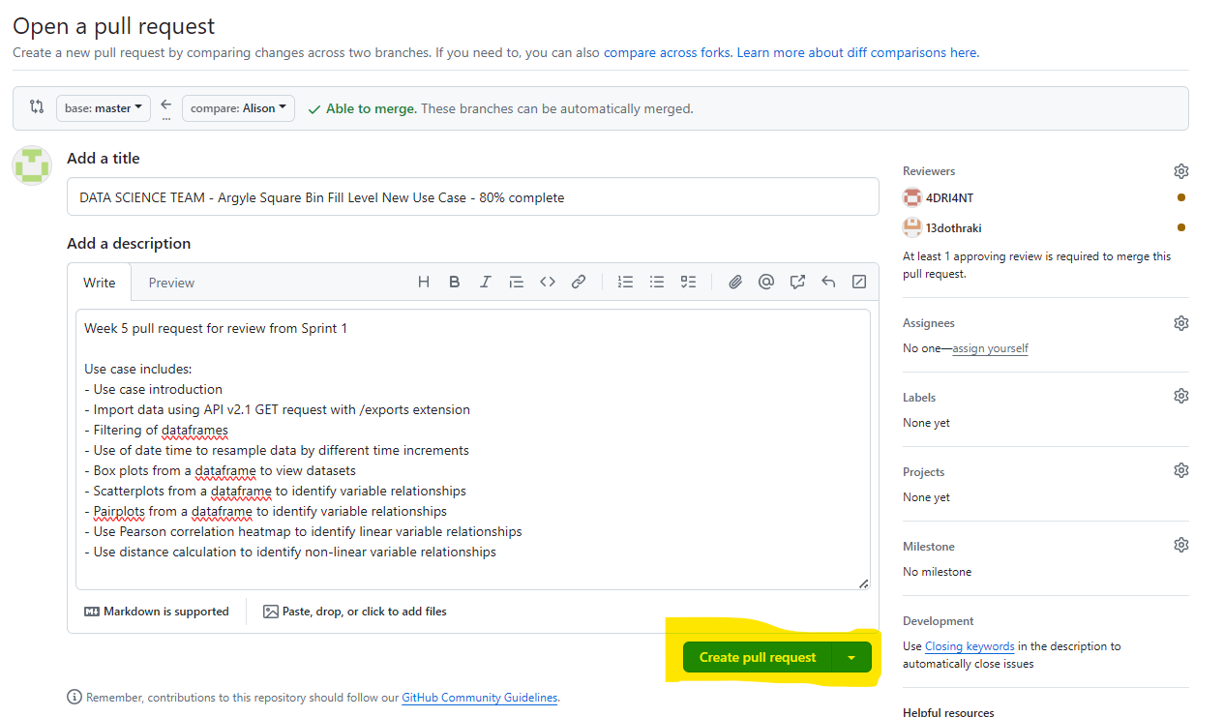

Reviewing a Pull Request from GitHub

# Select ‘pull request’ in top tab

If you are unsure where to start, choose sort and then sort by oldest

# Select the use case to open

When the use case is open, select the files changed tab.

If the use case is large, you will get a load diff. In this case, select the three dots on the right hand side and go to view file.

# Things to check for in the “Preview” view:

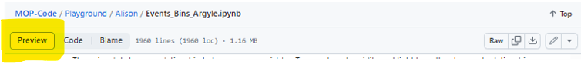

**Dataset import**

– Must be API v2.1

– API key must NOT be visible

**Comments in code sections**

– Must have a space and capital letter for first word

– Explain code in a way that can be easily followed

**Colours in graphs and tables**

– Adhere to Chameleon Company requirements

**Written explanations**

– Reason for methods chosen

– Explanations of output

*Remember: the use case is written*

*to teach people how to do this!*

*So explanation is important!*

# Things to check for in the “Code” view:

**HTML in code**

– HTML as per usecase TEMPLATE

## Further reading

Geeks for Geeks Full Commands List: [Git Cheat Sheet (2023) - All Git Commands (geeksforgeeks.org)](https://www.geeksforgeeks.org/git-cheat-sheet/).

## Author

Alison Collins, 2024